I installed [RStudio Connect QuickStart](https://www.rstudio.com/products/quickstart/) to test out some of the features. Basically, after you install it from this link you need to run it from an Oracle Virtual Machine, which simulates running the application on a server which is how you would run actual RStudio Connect.

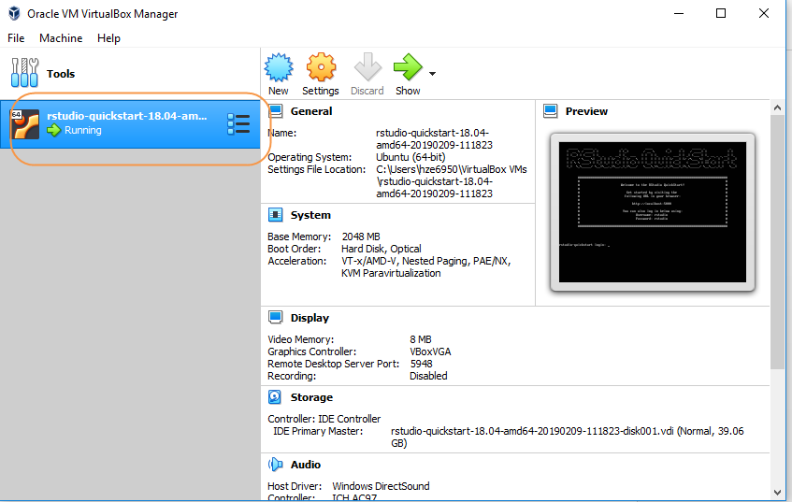

Once installed you connect to the RS Connect instance running on the virtual machine using a url that references your own machine. Once at the screen below hitting login will log you into an instance of RS Connect that has been pre-populated with content.

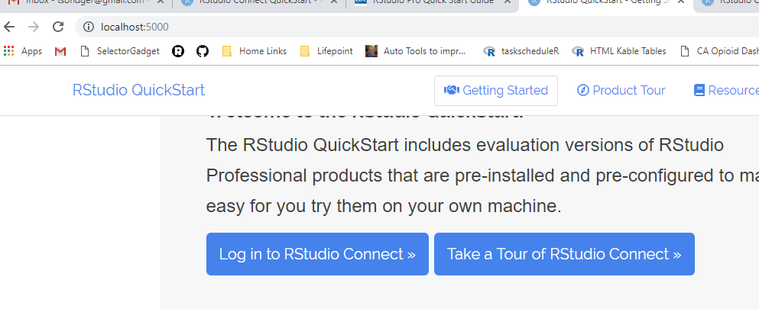

You can publish to this local server, however, due to storage issues on my computer I was not able to successfully publish any documents to it. I setup a connection between RStudio and RS Connect quite easily.

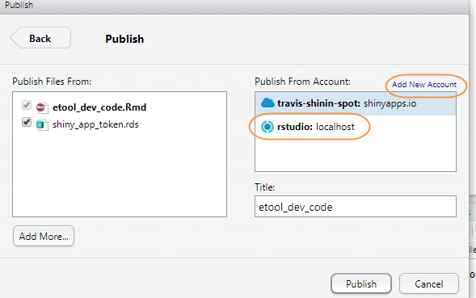

The RS Connect demo comes pre-populated with several examples. The one below is a pdf as well as PowerPoint example. On the right in the administrative tools settings you could set the report to update weekly and if the data underlying the report changed then the report would appear different after refreshing based on the set schedule. Additionally, you could set the report to auto email those included as viewers for this report whenever it updates. Viewers can choose to opt out of the report.

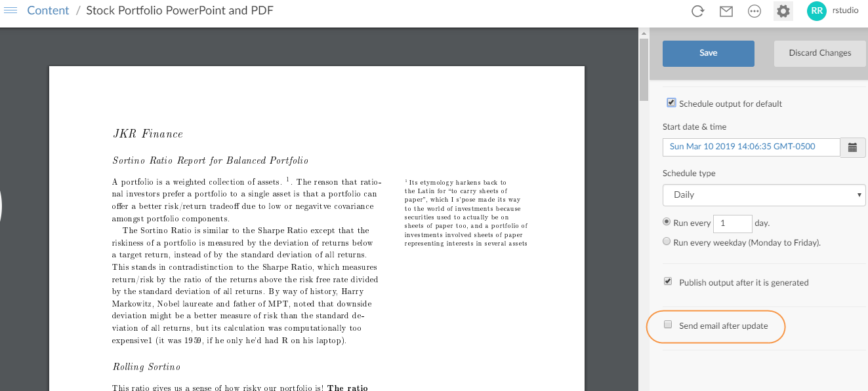

Above was an example of how RS Connect can be used to send a scheduled email. Below is an example of using RS Connect to send an email only if certain conditions are met. Below, an email is sent to the sales team only if sales are over 10,000, else they are not emailed the report.

